
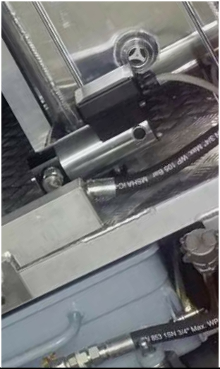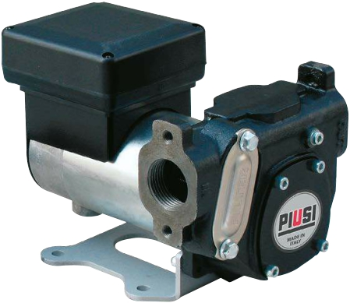

ปั๊มดูดน้ำมันดีเซล

DISPENSERS

METERS

NOZZLE

FILTRATION
FLUID
MONITORING

PANTHER DC

FEATURES
• STURDY STRUCTURE
• EASY TO INSTALL
• COMPACT DESIGN
• IP55

The PANTHER DC is a rotary, self-priming vane pump suitable for all applica- tions in which important flow rates are required. This equipment is fitted with an incorporated filter (100Μ) and by-pass valve. The 24/12 V version can be used with both voltages.

PERFORMANCE

UP TO
70 L/MIN

FLOW-RATE

30 MIN

DUTY CICLE

12/24V
VOLTAGE
POWER

PANTHER DC

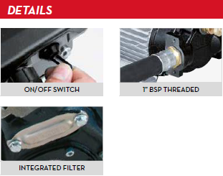

PACKAGING

